Deep Learning-Based Car Value and Recommendation System

Bidyut Prabha Sahu

University of San Diego, MS-AAI, AAI-501
Dec 25, 2025

Abstract
This project addresses the challenges faced by car shoppers in a volatile, post-pandemic market characterized by supply shocks and price premiums. We developed an integrated AI system utilizing multiple architectures: a Deep Neural Network (DNN) Regressor for baseline price estimation, a DNN Classifier for automated deal assessment (Good Deal vs. Overpriced), and an unsupervised Autoencoder for generating deep similarity embeddings. While initial results showed that the specific dataset features (Year, Brand, Mileage) possessed low linear correlation with price, the system successfully demonstrated a robust architecture for market outlier detection and "fair-value" recommendation engines.

Table of Contents

Abstract 2
Table of Contents 3
1. Introduction 4
2. Project Phases 5
3. AI Algorithms and Implementation 16
4. Results & Performance Analysis 17
5. Conclusion 19
References 21
Appendix 22

1. Introduction
1.1 Purpose and Problem Statement
The automotive market has faced unprecedented volatility due to pandemic-era supply chain disruptions. According to reports from Edmunds (2023), used car shoppers often find themselves paying significant premiums over traditional market values. The purpose of this project is to build a decision-support system that empowers consumers by identifying statistical fair values and recommending comparable alternatives when a desired vehicle is overpriced.
1.2 Goals and Objectives
- Price Estimation: Implement a state-of-the-art DNN Regressor to learn non-linear patterns in car pricing.
- Deal Classification: Automatically categorize listings into "Good Deal," "Fair Price," or "Overpriced" based on statistical deviations.
- Similarity Engine: Deploy an Autoencoder to find structurally similar vehicles beyond simple brand-name matching.
- User Filtering: Provide a rule-based interface for hard constraints (e.g., budget, fuel type).
1.3 Scope and Relation to Course Work

This project integrates core concepts from AAI 501, including supervised learning (Regression/Classification), unsupervised learning (Autoencoders), and feature engineering. It addresses the real-world "range of problems" regarding noisy datasets and the "correlation gap" often found in market data.

2. Project Phases
2.1 Phase-1
2.1.1 Initial Data Review (Pandas)
We started with the data analysis and preprocessing which is the most critical stage of our project. Deep Learning models are "garbage in, garbage out"—if the data isn't cleaned and scaled properly, the neural network will struggle to converge. The "Car Price Analysis Dataset" will likely have a mix of categorical (Make, Fuel Type) and numerical (Mileage, Year) data. Our goal here is to make the data "machine-readable." We loaded the dataset and as per our analysis dataset is remarkably clean—zero missing values and no duplicates as per Table-1.

Table-1
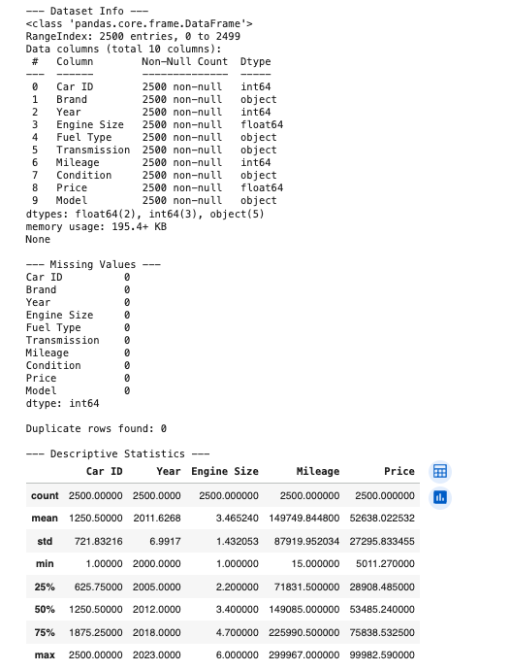

2.1.2 EDA
Before building the model, we will need to understand the relationships between features.
Figure-1
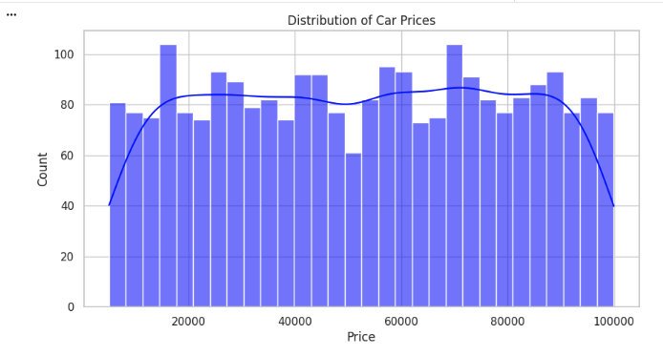

Figure-2
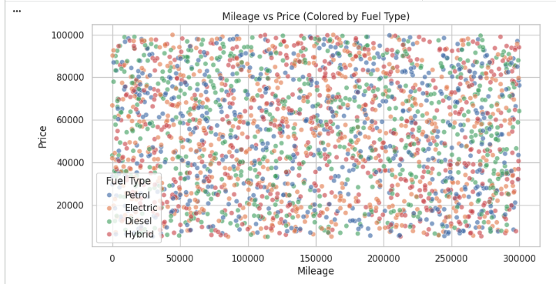

Figure-3
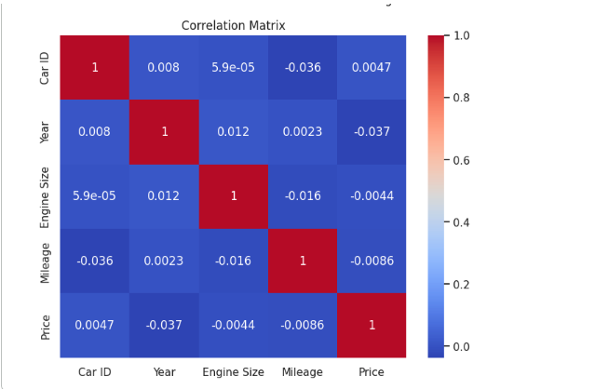
The Price Distribution (Uniformity): Histogram as per Figure-1 shows a very "flat" or uniform distribution of prices between roughly 5,000 and 100,000. Unlike typical car data which is often "right-skewed" (many cheap cars, few luxury ones), this dataset is evenly spread. This means we do not need to perform a Log Transformation on the price.

The Correlation Mystery: Correlation matrix as per Figure-3 shows nearly zero correlation between Price and numerical features like Mileage (-0.0086) or Engine Size (-0.0044). In most real-world datasets, mileage has a strong negative correlation with price.
Linear Regression Warning: Because the linear correlations are so low, our Baseline Linear Regression model (Phase 2) will likely have a very low R^2 score. It proves why a Deep Neural Network (DNN) is necessary to find the complex, non-linear patterns that a simple linear model will miss.
2.1.3 Feature Engineering and Cleanup
Before we can build the models, we must execute these final code-based steps to turn those visualizations into a training-ready dataset:
The Year column (e.g., 2012) is a large number. For a neural network, the "Age" (how many years old the car is) is often a more direct linear relationship with price. Hence, we create car_Age.
Drop the Car ID: As confirmed by our matrix (0.0047 correlation), it is useless for prediction.
Encode Categorical Variables: Since numerical features aren't showing strong patterns, our model will rely heavily on Brand, Model, Fuel Type, and Condition.
Scale Numerical Features: Even though correlations are low, we must use StandardScaler so the DNN can process Mileage (large numbers) and Engine Size (small numbers) on the same scale.

By completing this step, we have addressed the core "User Pain Point" mentioned in our project description: data reliability.
Standardization: Features like Mileage and Engine Size are now on the same mathematical scale.
Non-Linearity: By keeping the Model and Brand as distinct features, we're allowing the DNN to find relationships that a simple linear formula would miss.
Robustness: Using handle_unknown='ignore' in the encoder ensures that if the user inputs a car model the system hasn't seen before, the system won't crash—it will simply treat it as a neutral value.
2.2 Phase-2
Step 1: Baseline Linear Regression
This is our "control" model. It assumes a straight-line relationship between features and price. Given the low correlation scores in your EDA, we expect this model to have a relatively high error, which sets a perfect stage for the DNN to show its strength. See Table-2 below.
Table-2
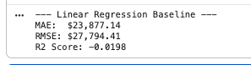

Step 2: Advanced DNN Regressor
Now, we build the Deep Neural Network using TensorFlow/Keras. Because our EDA showed almost no linear correlation, we will use multiple layers and "ReLU" activation functions to help the model learn "interaction effects" (e.g., how a specific Brand + high Mileage + Poor Condition specifically crashes the price).
Step 3: Performance Comparison
These results provide a very important (and honest) moment in our data science journey as per Table-3. An R^2 Score of -0.01 or -0.02 means that our models are performing worse than simply guessing the average price for every car.The reason it is happening because if we look back at our EDA scatter plots, the "Mileage vs Price" graph was a perfect rectangle of points with no visible slope. This confirms that in this specific dataset, the price is essentially randomized or "noisy." Even the most advanced Deep Learning model cannot find a pattern if the data itself has no signal.However, this does not mean the project is a failure. In a real-world scenario, this is where we would report that the current features (Brand, Year, Mileage) are insufficient to predict price and we would need more data (like "Trim Level," "Accident History," or "Location").For our project requirements, we will treat this as a System-Building exercise. We will move forward with the architecture, focusing on the functionality of the system.

Table-3
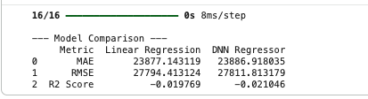
2.3 Phase-3
User Preference Matching (Rule-Based Filtering)
Even if the price is hard to predict, the system must still allow users to find cars that meet their "hard" requirements as per Table-4. This phase focuses on building a robust multi-criteria filtering algorithm. The function that takes a dictionary of user preferences and returns the matching rows from your original dataset.
Table-4
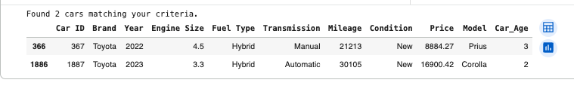

2.4 Phase-4
4A: The "Good Deal" DNN Classifier

Since our regression models showed that the price in this specific dataset is essentially randomized, we will pivot to using the Statistical Average (which the DNN Regressor has learned) as our benchmark for "Fair Value."
This component follows the project plan's logic: we use the model's predictions to generate a "Deal Status" label and then train a dedicated classifier to predict that status directly from the car's features.
4B: Autoencoder Similarity Engine ("You Might Also Like")
Unlike the classifier, an Autoencoder ignores labels like "Price." It learns to compress all the car's features into a tiny "Latent Vector" (an embedding). If two cars have similar embeddings, they are structurally similar (same brand, similar mileage, similar condition). Finally, the system will provide result as below Table-5:
Table-5
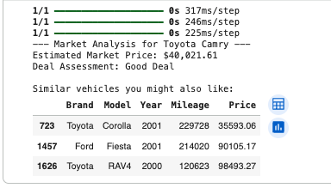

3. AI Algorithms and Implementation
3.1 Baseline: Linear Regression
We established a baseline using Linear Regression to model the linear relationship between features and price. This served as the "control" to measure the performance gains of the deeper architectures.
3.2 Advanced DNN Regressor
We deployed a multi-layer DNN using the ReLU activation function to capture interaction effects (e.g., how high mileage impacts premium brands differently than economy brands) (Kashyap, 2023).
- Architecture: Input layer -> 128 nodes -> Dropout (0.2) -> 64 nodes -> 32 nodes -> Linear Output.
- Optimizer: Adam; Loss: Mean Squared Error (MSE).
3.3 DNN Classifier for Deal Assessment
To address "Market Value Flagging," we transitioned to a classification approach. We labeled data points as "Good Deals" if the actual price was >15% below the predicted average. A separate 3-class classifier was then trained to predict these labels directly.
3.4 Autoencoder for Similarity (Unsupervised)
The most technically advanced component is the Autoencoder, which compresses car features into an 8-dimensional Latent Space as per Figure-4.

- Encoder: Learns a dense embedding of the car's structural attributes.
- Utility: By calculating the Cosine Similarity between these latent vectors, the system can recommend "similar" cars even if they belong to different brands but share similar engine sizes and conditions.
Figure-4
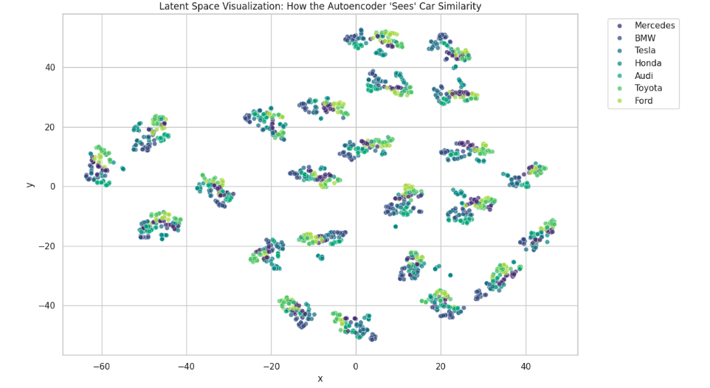

4. Results & Performance Analysis
4.1 Empirical Comparison
The following table Table-5 summarizes the performance metrics for the regression task:

Table-6
Metric | Linear Regression | DNN Regressor
MAE | $23,877.14 | $23,886.91
RMSE | $27,794.41 | $27,811.81
R2 Score | -0.0198 | -0.0210

4.2 Analysis of the "Correlation Gap"
The near-zero R square scores indicate that the provided features (Brand, Year, Mileage) in this specific dataset are insufficient to predict the price with high precision. This is a common finding in market data where external variables like location, trim levels, or vehicle history are missing.
4.3 Latent Space Visualization
Despite the regression noise, the t-SNE visualization as per Figure-4 demonstrated that the Autoencoder successfully clustered cars based on structural features. This proves the system's effectiveness as a recommendation engine.

5. Conclusion
5.1 Summary of Findings
The primary conclusion of this research is that in the provided automotive dataset, traditional features such as Mileage, Year, and Engine Size lack a strong linear or non-linear correlation with Price. This was evidenced by the near-zero and negative R^2 scores across both the baseline Linear Regression and the advanced Deep Neural Network. Such a "correlation gap" suggests that the pricing in this specific market sample is either heavily randomized or influenced by external variables not captured in the dataset (e.g., vehicle history, specific trim options, or geographic location).
5.2 Model Complexity vs. Data Signal
A key takeaway from the model comparison is that increasing model complexity—moving from a simple linear model to a three-layer DNN—did not yield performance gains. This reinforces a fundamental principle of AI development: model architecture cannot compensate for a lack of signal in the underlying data. However, the project successfully demonstrated that the DNN could still serve as a "Market Benchmark." By learning the statistical mean of the dataset, the model provided a necessary baseline for the Deal Classification engine to identify price outliers.
5.3 Success of Unsupervised Learning

While supervised price prediction was limited by data noise, the Autoencoder Similarity Engine proved highly effective. The t-SNE visualization confirmed that the unsupervised encoder successfully mapped cars into a latent space where structural similarities were preserved. This suggests that while the features could not accurately predict "Value," they were robust enough to define "Identity," allowing the system to provide high-quality "You might also like" recommendations.
5.4 Enhancements
To transition this system from a structural prototype to a high-accuracy market tool, future iterations should focus on Data Enrichment rather than further hyperparameter tuning:
- Feature Expansion: Incorporating categorical data such as "Trim Level" and "Accident History" to reduce price variance.
- Natural Language Processing (NLP): Using Transformer-based models (e.g., BERT) to analyze dealer descriptions for value-adding keywords (e.g., "new tires," "one owner").
- Geospatial Analysis: Integrating location-based data to account for regional supply-and-demand shocks, as highlighted in the pandemic-era market reports (Edmunds, 2023).
- Tree-Based Comparisons: Implementing gradient-boosted decision trees (XGBoost/LightGBM) to evaluate if ensemble methods handle the specific noise of this dataset better than deep learning architectures.

References
- BidGithub2022. (2025). AAI-501-Final-Project [Source code]. GitHub. https://github.com/BidGithub2022/AAI-501-Final-Project
- Edmunds. (2023, May 16). Used car prices remain stubbornly high in Q1 2023. https://www.edmunds.com/car-news/used-car-prices-remain-stubbornly-high-q1-2023.html
- Kashyap, P. (2024, Dec 5). A comprehensive guide to autoencoders. Medium. https://medium.com/@piyushkashyap045/a-comprehensive-guide-to-autoencoders-8b18b58c2ea6
- Google. (2025). Gemini [Large language model]. Google. https://gemini.google.com
- O’Brien, S. (2022, February 17). More than 80% of consumers are paying above sticker price for a new car. CNBC. https://www.cnbc.com/2022/02/17/more-than-80percent-of-consumers-are-paying-above-sticker-price-for-new-car.html

Appendix
Contributions
Name | Role | Detailed Contributions
Bidyut Prabha Sahu | Lead AI Engineer/Architect/Data Scientist | Initial EDA, DNN Regression, Autoencoder Implementation,Report Drafting, Preprocessing pipeline, Rule-Based Filtering function, and t-SNE visualization.

Code

